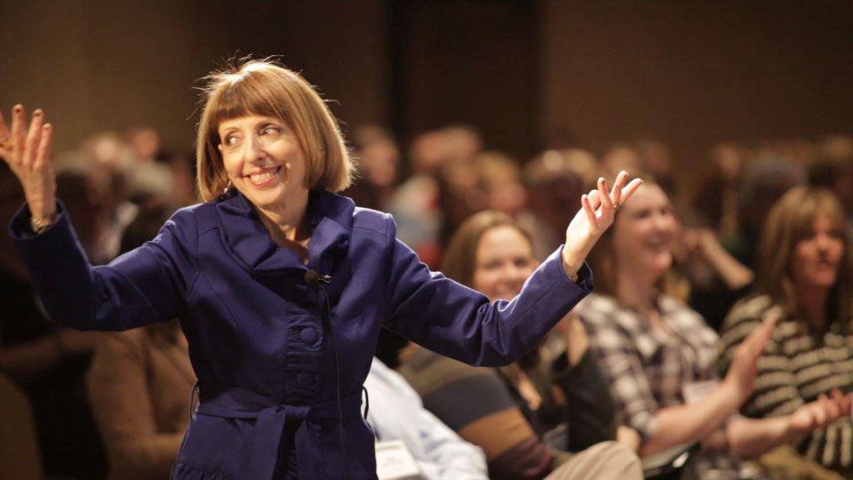
About Max:
C O A C H • S P E A K E R • T R A I N E R

_________________________________________________________________________________________
From The Feds to FOX, Papyrus to Zappos, find out why clients call Maxine “Phenomenal!” These Highly interactive keynotes and workshops become a playground for boldness, agility and forward-thinking ideas.

Collaborcate!™
Imagine, 7, 70 or 700 of your leaders and/or teams fully engaged, interacting, laughing while learning AND experiencing new ways to have productive, speedy and fun Collaborations, more positive and generous Communications, while Creating results far beyond anyone’s vision. The take-aways are used immediately and for years to come.

Inspiring an Awesome, Outrageous Legendary Customer Experience!
“By 2020, Customer Experience will overtake price and products as the key brand differentiator” (Walker)
And, 86% of buyers will pay more for a better customer experience. So, let’s give it to them.
In this lively session, we’ll have our own experience and learn what are the key components of an Awesome Experience and how to make a neutral customer into your Promoter. A win-win for all!

Maxine is a dynamic speaker, training professional and coach whose quick wit and business savvy has created a national demand for her Collaborcate!™ keynotes and workshops. Maxine is a 25-year veteran of the business world - from the floor of the Chicago Board of Trade to being a weekly financial commentator on NPR’s “Marketplace,” (one of the most widely listened business broadcasts in the country). She’s also an accomplished actor and comedienne and was a student of the Second City Improv Lab.

Max motivates, inspires, entertains, and transforms groups using one of the most exhilarating forces in business today – IMPROVISATION. No death-by-PowerPoint here! The take-aways are used immediately and for years to come. These unique tailor-made presentations, translate to every industry who crave boldness, agility and more positive communications that quickly move into innovation and implementation. Experience what 100’s of organizations, call “Remarkable!” “Transformational!” “Energetic!” & "Contagious!"
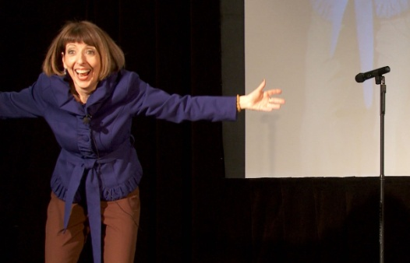

Vestibulum bibendum pede quis mi semper
In et aptent posuere sapien tempor, id nullam fermentum consequat metus ut. Hasellus quam dolor dui, vehicula a id fermentum amet. Sapien in, quo vestibulum, viverra vitae.

How to Keep a Millennial Longer Than 6 weeks -
It’s more than a ping pong table
How do you position your company to acquire and retain the best and the brightest employees? You become the best and the brightest place to work, making you the Employer of Choice.

In this keynote/workshop through highly interactive exercises, we'll identify and define YOUR Culture. Not Google’s, not Facebook’s. Yours. It's important to recognize that what Millennials want in the workplace is shared by the majority of your employees. Nobody who graduated from college says, “I can’t wait to be micro-managed...”
In this presentation you will experience how to:
1. Address, laugh and move beyond the generational stereotypes to authentic empathetic conversations.
2. Tap into dormant talent – to have ideas heard - more collaboration and innovation on-demand.
3. Trust and engage employees to implement their solutions and ideas.
4. Inspire an authentic culture that expresses the business goals through solution-focused communications.
And, for managers, we'll answer the question, "Do I have to treat everyone differently?” As in all my keynotes and workshops, I use the application of improv which allows for more authenticity, spontaneity, and agility.
“Your exercises were an absolute hit with everyone. They loved getting involved and have praised your performance! I would say that Maxine is absolutely phenomenal! …And recommend utilizing her talents for any motivational presentation.”
Candice C, Program Dir, Federal Reserve System Annual Summit

"I just wanted to take a minute to share how amazing my experience or the "Inside the Box" training was. Here at Zappos, we are encouraged and empowered to integrate our passions into whatever job it is we are doing. ..I loved your energy and commitment to every second of the day. The games were impactful, entertaining, thoughtful, created connection with the whole class. All in all, it was the most eye-opening seminar I've ever been to... Thank you again for your commitment to the process!”

Zappos.com Training Director

“I thought your keynote was fantastic and really set us up well for the remainder of the conference which was a blistering success. Thank you and please stay in touch.”
Lee A. Senior VP, Federal Reserve Bank of New York
“Maxine was super! Very engaging, articulate, interesting and entertaining! Maxine was on fire! She is an amazing instructor and should be paid TONS of money, please give her a raise…”

Managers – FOX Entertainment Group

"Max is a spitfire and will literally have you jumping out of your seats! She is at the same time very warm and engaging. She really understands people and human behavior. Soooo thrilled with what she presented at City Club and ever so grateful”

Kristy A, Los Angeles Mission

“If you want a boring, typical presentation don't hire Max! If you're looking for a dynamic presentation that will "wake up" your group then you should hire her! Attendees will be pleasantly delighted with her energy, presentation style and takeaways”

Mitch W., DOO,E-MARKETING Associates

Watch Max in Action!
Contact Maxine:
214.455.1093
maxine@maxineshapiro.com
Traveling from Los Angeles

